Mahnoor

19F-0965  SE-4A

SSD Lab 8

# Project SSD of extended use cases:

Project name:

**Rent A Ride- Bus/Car riding and car booking system.**

Roll numbers:

**19F-0909**

**19F-0915**

**19F-0965**

Manage Cars:

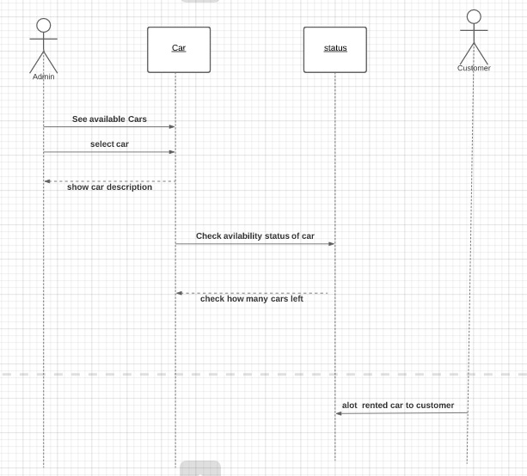

Manage driver: 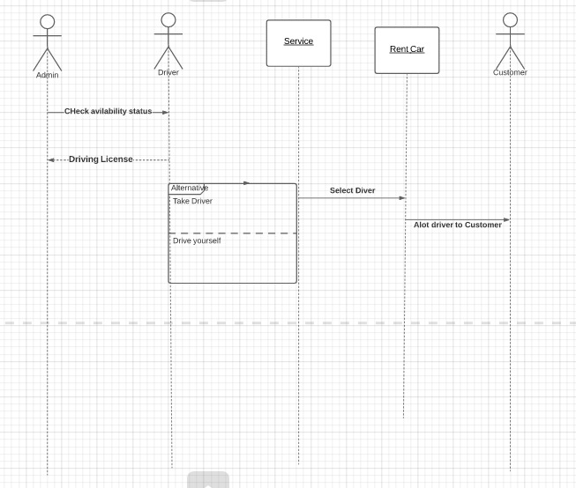

Rent car: 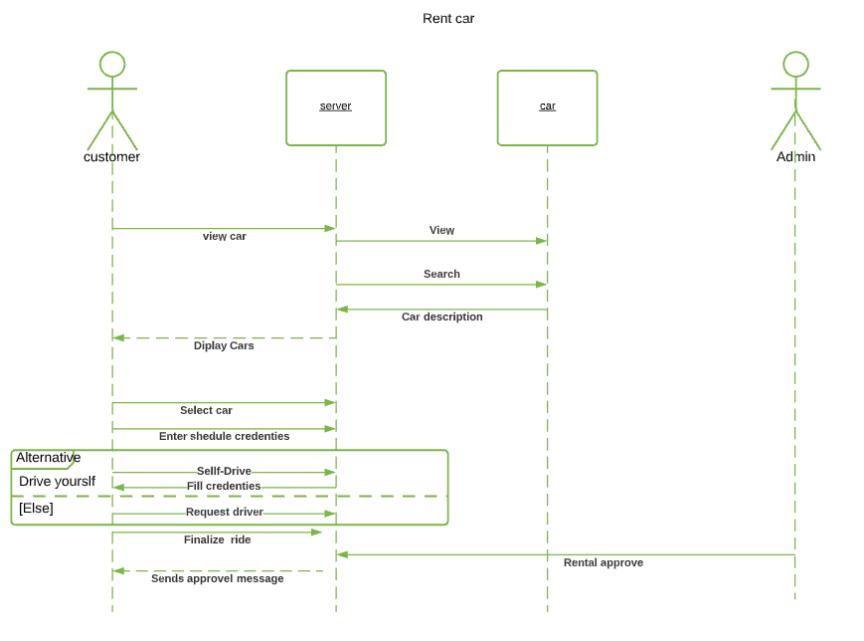

Ride: 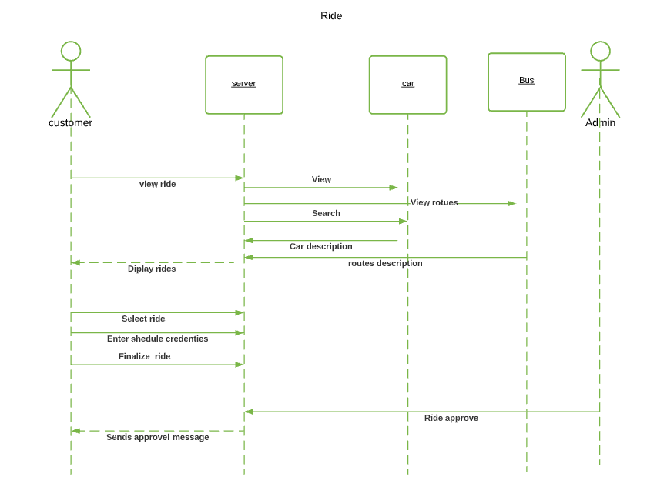

Payment method: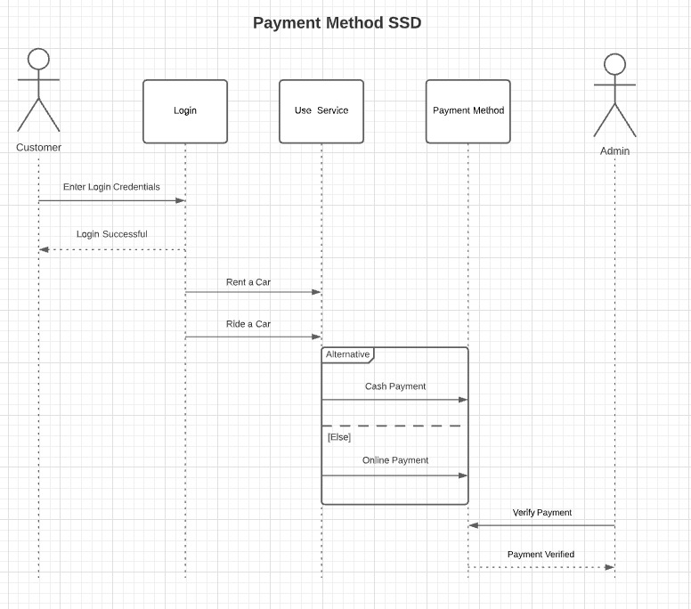Self-drive: